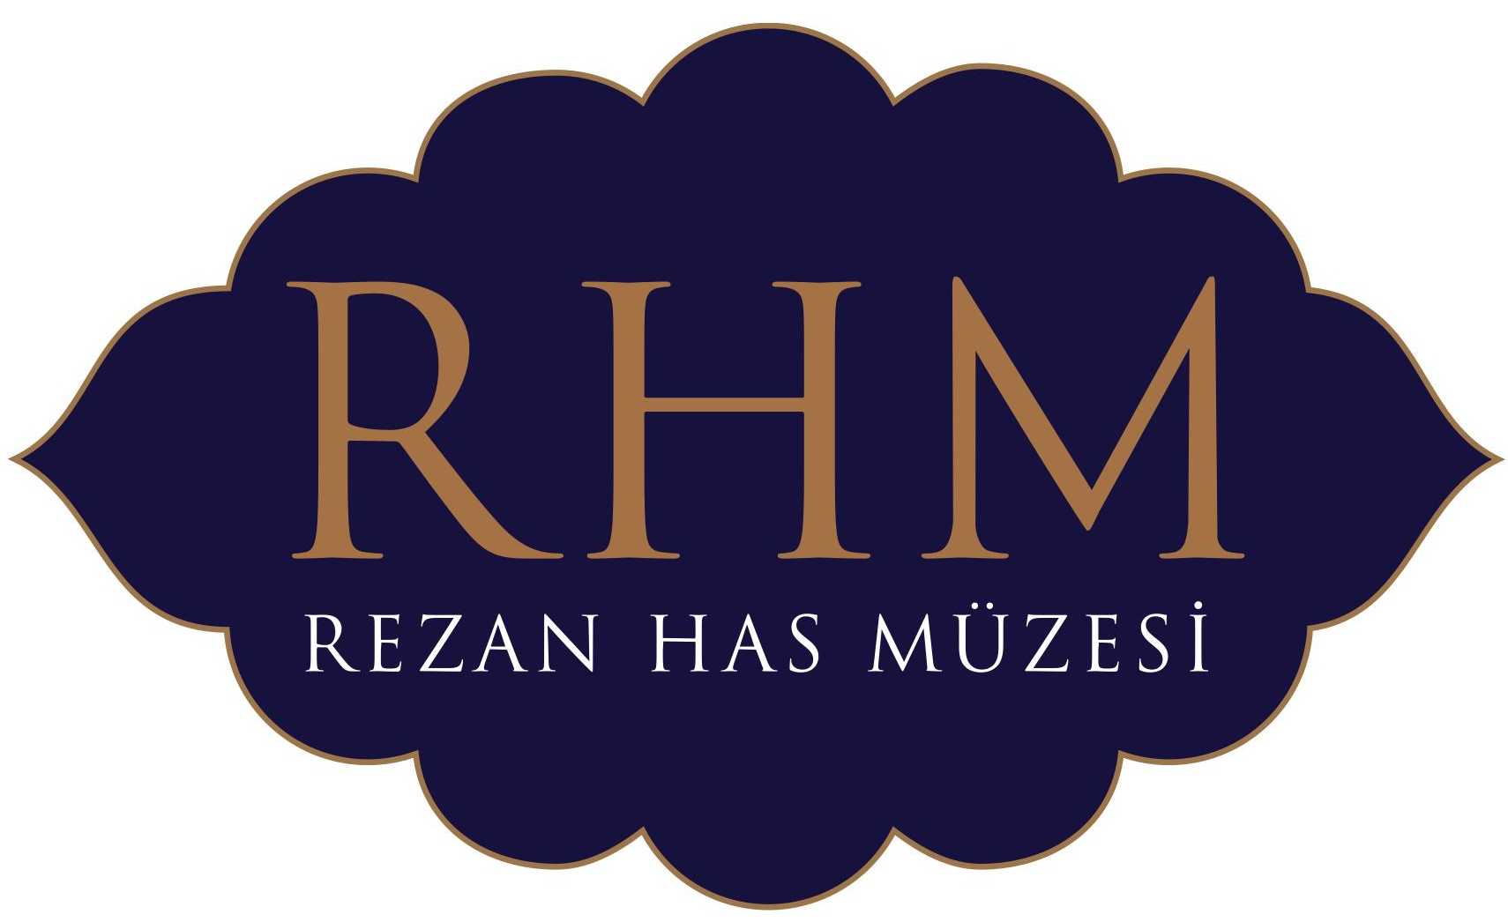

PAINTER OF THE LIGHT: HOMMAGE AN NAZMİ ZİYA GÜRAN

“PAINTER OF THE LIGHT: NAZMİ ZİYA GÜRAN” EXHIBITION WILL MEET THE ART LOVERS IN FEBRUARY AT THE REZAN HAS MUSEUM.

Rezan Has Museum is happy to present the **"Painter of the Light: Nazmi Ziya Güran"** exhibition which will show a special selection of the artist's works from different private collections to the art lovers. The works by Nazmi Ziya Güran whose 75th anniversary of death is being celebrated this year can be seen between February 18, and April 17, 2012 at the Rezan Has Museum.

As one of the painters of "1914 Generation", Nazmi Ziya Güran was a part, observer, witness and painter of Istanbul, all the time during its occupation or during the following years of the new Turkish Republic was the most intensive at his parental home in Horhor district in Aksaray, in Çamlıca, Süleymaniye or in his large windowed studio, in Bosphorus, Golden Horn, Üsküdar, on seaside, city hills, the streets and countryside.

While sliding his brush through gardens and parks, trees, orchards, countrysides, streets and quarters, villas and mansions, seasides and docks of this beautiful city; he described Istanbul’s sea, boats, mosques and churches, mausoleums, coffee-houses, fountains and the passing lives of people in Istanbul in this natural and urban environment.

One of the first impressionist painters of Turkey, Nazmi Ziya Güran was influenced in his works which are shining with light and joy by the thousand gleams of sun, and reflected them on canvas with the same reality. The peace and happiness that we feel at the artist’s brushstrokes which he throws as he would flirt with light tell us the adventure of Nazmi Ziya Güran after light.

“Painter of the Light: Nazmi Ziya Güran” exhibition with 65 works specially selected from private collections and the collection of Istanbul Painting and Sculpture Museum by Nazmi Ziya Güran who was the most important Turkish representative of 19th century French painting movement Impressionism is welcoming the art lovers until April 17th at the Rezan Has Museum.

*\*\*\* The exhibition “Painter of Light: Nazmi Ziya Güran” will be opened on 17th of February, 2012 with the attendance of the Cultural Minister of Republic of Turkey Mr. Ertuğrul Günay and can be seen until 17th of Aril, 2012.*

*\*\*\* The exhibition catalogue published with the contribution of Ergo will be available from 17th of February on for all art lovers.*

“PAINTER OF THE LIGHT: NAZMİ ZİYA GÜRAN”

FEBRUARY 18 ‒ APRIL 17, 2012

**REZAN HAS MUSEUM**

**Kadir Has University**

**Kadir Has Cad.**

**Cibali–Haliç**

[**www.rhm.org.tr**](http://www.rhm.org.tr)

**Telephone : 212 5336532**

**Visiting Hours : 9:00-18:00 (Except religious and national holidays and first day of the year)**

**For information:**

**Özge Ercan**

**212 533 65 32 (1121)**

**ABOUT ERGO**

With 144,6 million TL capital from the end of 2010 on, around 694 million TL premium, 515 full-time employees, 13 district offices throughout Turkey, more than 1500 agencies and network of contracted firms, ERGO Sigorta is one of the leader insurance companies in the sector. Supporting its clients in all circumstances with responsibility and competence, ERGO Sigorta meets all insurance needs of its customers and guarantees a lifetime of cooperation. ERGO Sigorta offers products and services in 7 main areas such as Fire, Car Accident, Non-Car Accident, Engineering, Transportation, Agriculture, and Health. The mission of ERGO Sigorta is to grow while giving particular attention to client satisfaction and to continue being one of the biggest insurance companies in Turkey while always supporting its clients.

With our best thanks…

