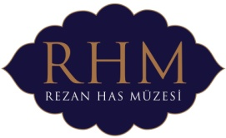

DREW TAL’S EXHIBITION “FACING EAST” IS
AT THE REZAN HAS MUSEUM

Drew Tal: "My art is a personal investigation across cultural bounds into the underlying human themes and common spiritual threads found in religious, mythological and sexual expression”.
Rezan Has Museum hosts Drew Tal who is known for his works, some of which have already been included in the permanent collections of the Norton Museum of Art and New Britain Museum of American Art. The works showcased in the exhibition, in which the underlying theme is ethnicity, are grouped under four titles: “Facing East”, “Light from Within”, “Infallible Symmetry” and “Veiled, Unveiled”

The Exhibition “Facing East” featuring and bringing photographic artist Drew Tal’s works which are described as having a more edgy, confrontational and provocative nature by the artist himself to art lovers will be on view between 14th September and 31st October 2013 at the Rezan Has Museum.

* This event is organized within the context of the 13th İstanbul Biennial Parallel Events Program

www.rhm.org.tr
www.facebook.com/RezanHasMuseum

